|  |  |
| --- | --- |
|  | **AMERICAN INTERNATIONAL UNIVERSITY-BANGLADESH (AIUB)**  Faculty of Engineering  Department of EEE and CoE  Undergraduate Program |







|  |  |
| --- | --- |
| **Course: Data Communication** | **Fall 2021-22, MID** |

**Experiment 1: Introduction to MATLAB**

**Submitted by:**

|  |  |  |
| --- | --- | --- |
| **Name** | **ID** | **Contact Details** |
| ASIF SHARIF AKASH | 20-42647-1 | 20-42647-1@student.aiub.edu |

**Section**: F

**Group**: 7



**Submitted To**

**AFSAH SHARMIN**

Lecturer

Faculty of Engineering   
American International University-Bangladesh

**Performance Task for Lab Report: (ID = AB-CDEFG-H)**

ID = 20-42647-1

So,

A = 2

B = 0

C = 4

D = 2

E = 6

F = 4

G = 7

H = 1

x1(t) = A1 cos(2π(CDEF)t + j1)

x2(t) = A2 cos(2π(CDEF)t + j2)

A1 = AB = 20

A2 = GH = 71

j1 = DG = 27°

j2 = 30°

x1(t) = 20cos(2π(4264)t + 27°)

x2(t) = 71cos(2π(4264)t + 30°)

**(a)**

MATLAB Code:

A1=20;

A2=71;

j1=27*(pi/180);

j2=30*(pi/180);

t=0:pi/100:2*pi;

x1=A1*cos((2*pi*4264*t)+j1);

plot(t,x1,'m','linewidth',2);

hold on;

x2=A2*cos((2*pi*4264*t)+j2);

plot(t,x2,'r','linewidth',2);

hold on;

title("(a)");

xlabel("Time");

ylabel("Amplitude");

Output:

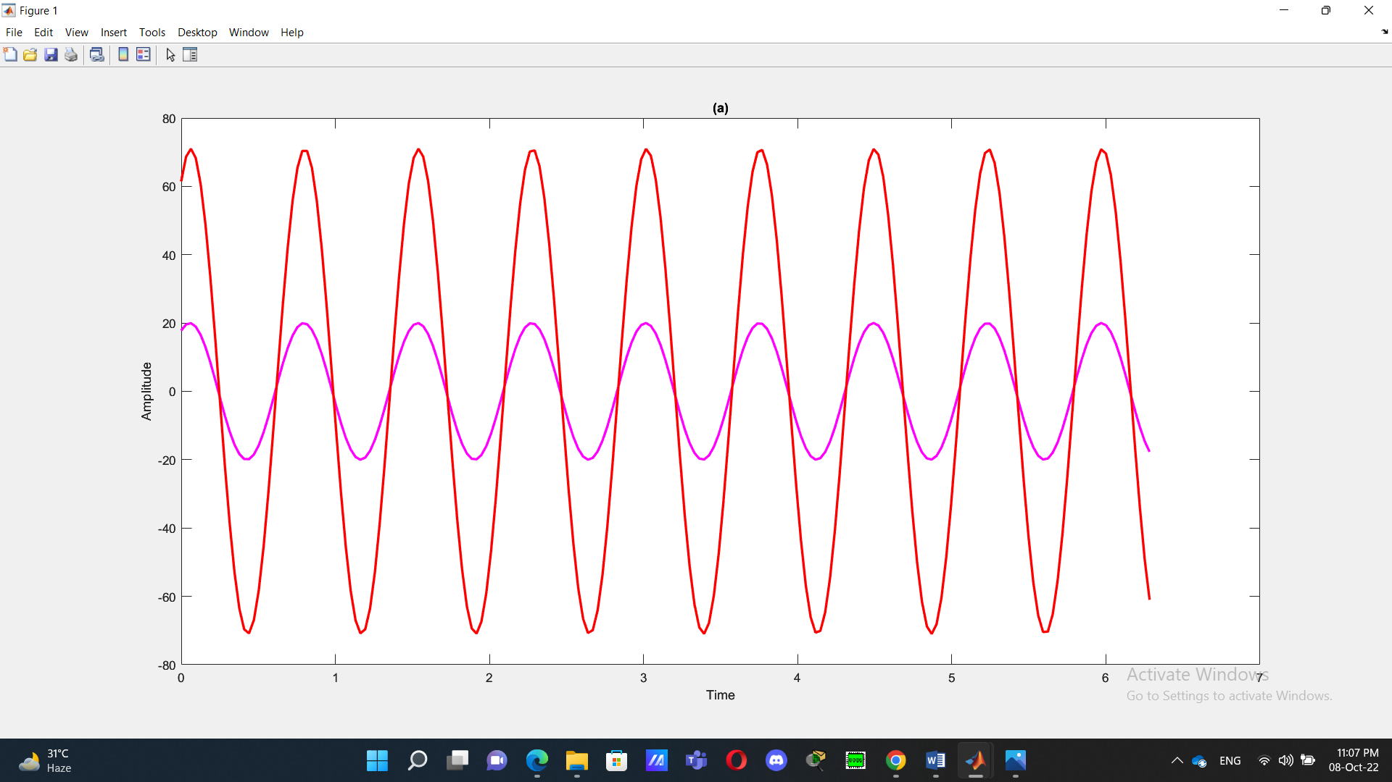

**(b)**

MATLAB Code:

A1=20;

A2=71;

j1=27*(pi/180);

j2=30*(pi/180);

t=-2*pi:pi/20:2*pi-pi/20;

x1=A1*cos(2*pi*4264*t+j1);

x2=A2*cos(2*pi*4264*t+j2);

plot(t,x1,'b',t,x2,'m')

title("(c)")

xlabel("Time")

ylabel("Amplitude")

Output:

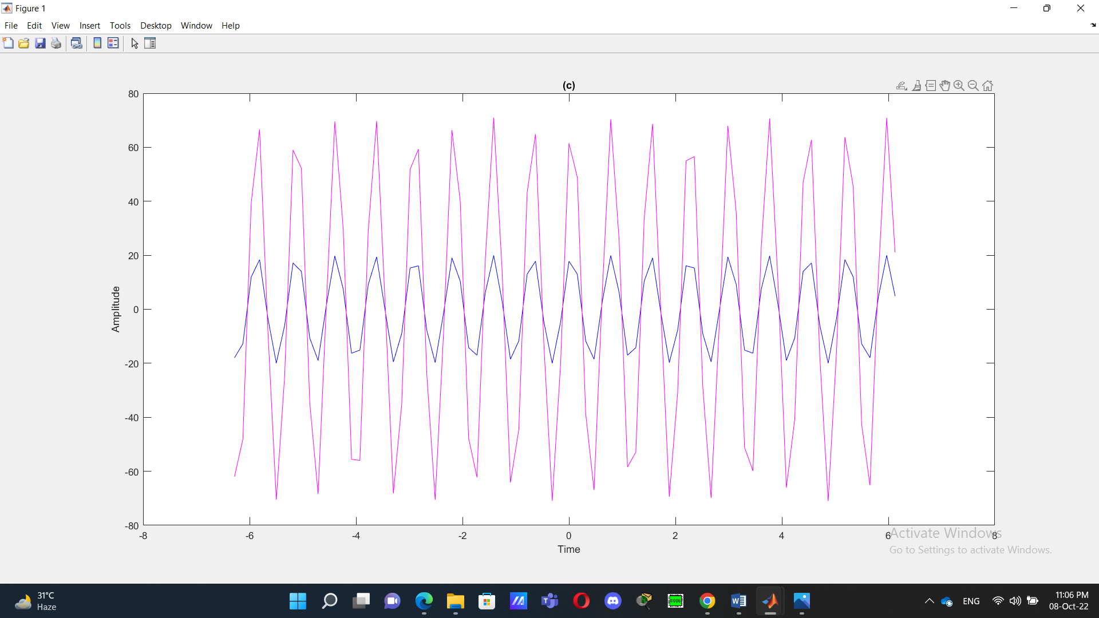

**(c)**

Here we can see from the graph that x1(t) reaches its maximum peak after t=0 and x2(t) reaches its maximum peak at t=0.

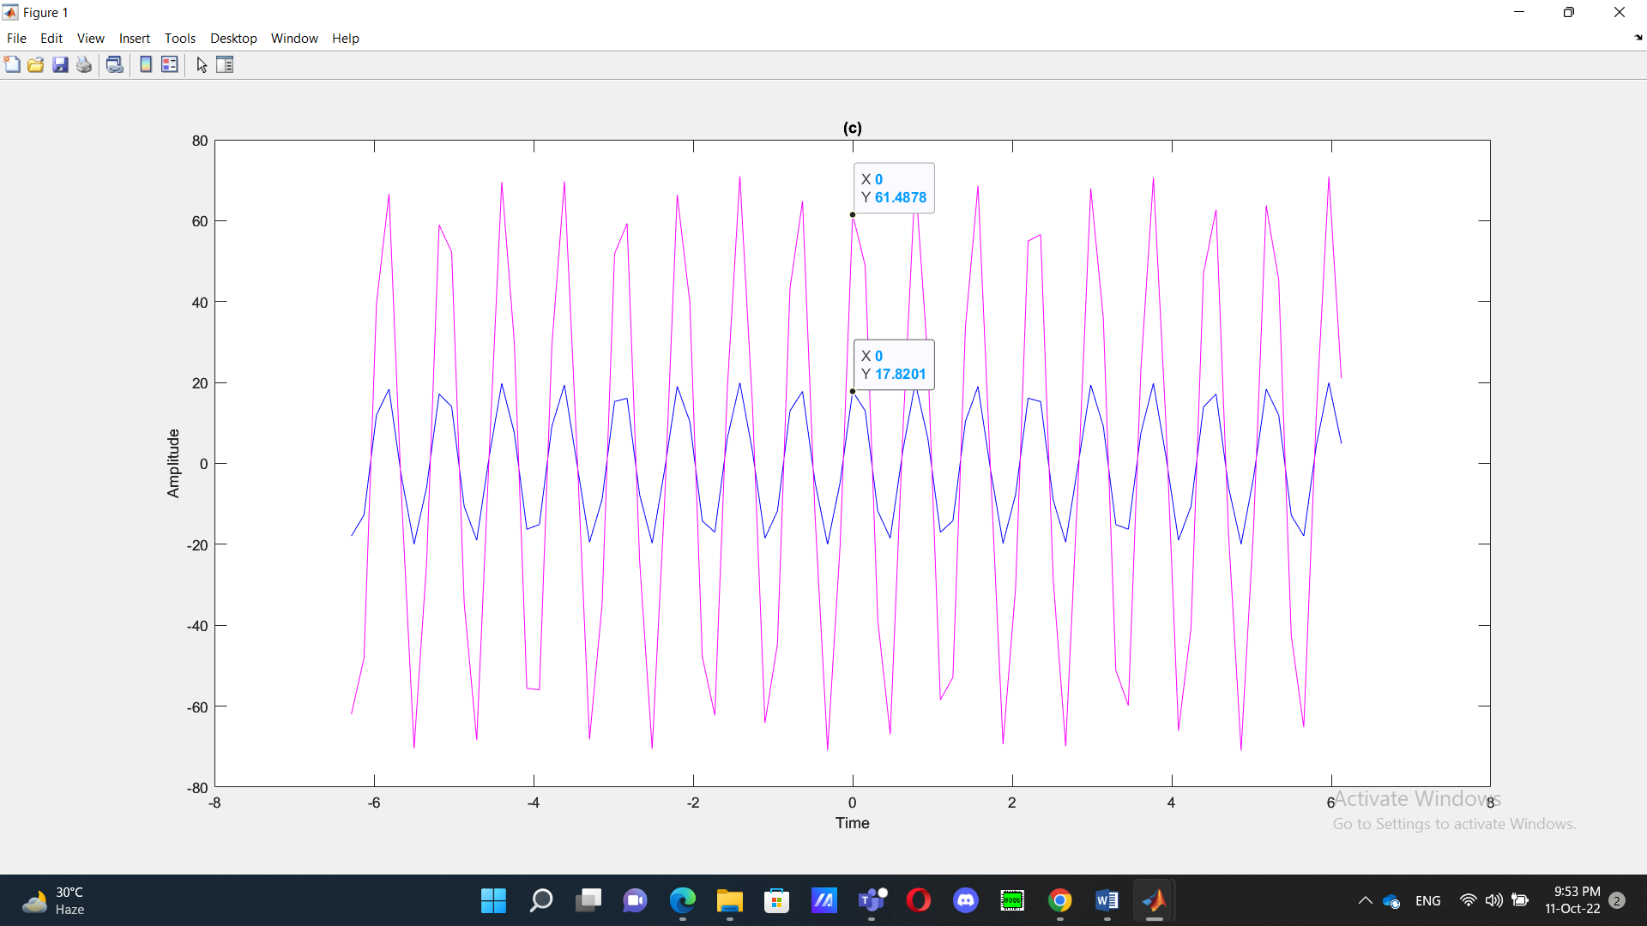

x1(t) reaches its peak A1=61.49 when t=0

x2(t) reaches its peak A2=17.82 when t=0

**(d)**

MATLAB Code:

A1=20;

A2=71;

j1=27*(pi/180);

j2=30*(pi/180);

t=-2*pi:pi/40:2*pi-pi/40;

x1=A1*cos(2*pi*4264*t+j1);

x2=A2*cos(2*pi*4264*t+j2);

subplot(3,1,1)

plot(t,x1,'g')

xlabel("Time")

ylabel("Amplitude")

title("x1(t)=A1*cos(2*pi*4264*t+j1)")

subplot(3,1,2)

plot(t,x2,'m')

xlabel("Time")

ylabel("Amplitude")

title("x2(t)=A2*cos(2*pi*4264*t+j2)")

Output:

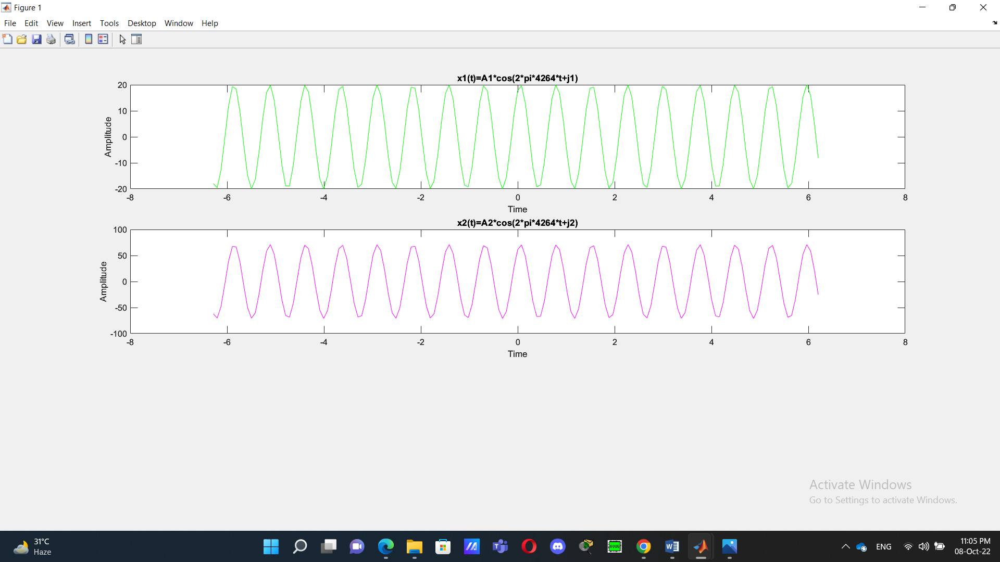

**(e)**

MATLAB Code:

A1=20;

A2=71;

j1=27*(pi/180);

j2=30*(pi/180);

t=-2*pi:pi/40:2*pi-pi/40;

x1=A1*cos(2*pi*4264*t+j1);

x2=A2*cos(2*pi*4264*t+j2);

x3=x1+x2;

subplot(3,1,1)

plot(t,x1,'c')

xlabel("Time")

ylabel("Amplitude")

title("x1(t)=A1*cos(2*pi*4264*t+j1)")

subplot(3,1,2)

plot(t,x2,'k')

xlabel("Time")

ylabel("Amplitude")

title("x2(t)=A2*cos(2*pi*4264*t+j2)")

subplot(3,1,3)

plot(t,x3,'m')

xlabel("Time")

ylabel("Amplitude")

title("x3(t)=x1(t)+x2(t)")

Output:

